Prithwi Secondary Boarding School

Final-Term exam

Class: L.K.G F:M=50

Subject: Social/Science P:M=20

Q.NO.1. Match the letters to the correct picture. [5]

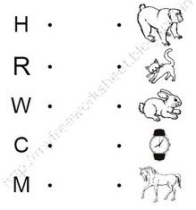

Q.NO.2. Match the body parts with their name. [8]

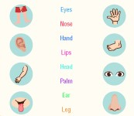

Q.NO.3. Write the first letter of each fruits. [9]

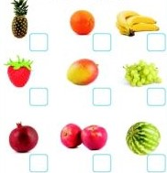

Q.NO.4. Fill in the missing letters. [5]

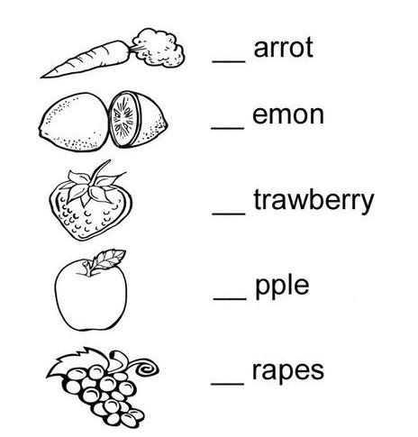

Q.NO.5. Name them. [12]

1) Vehicles :- …………………………. , ……………………………..

2) Big animal:- …………………………… , ……………………………

3) Food from plants:- …………………………….. , …………………………………

Q.NO.6. Match the vehicles with their name. [7]

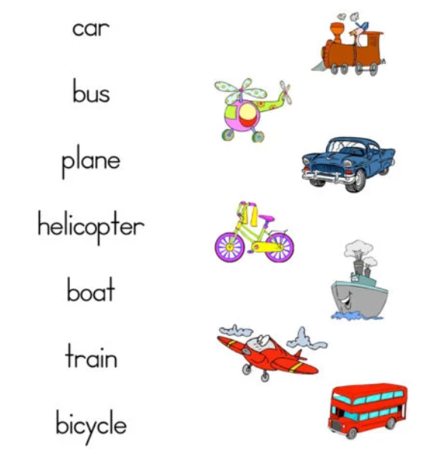

Q.NO.7. Colour it. [4]

